# C:\Users\sec.registraracad\AppData\Local\Microsoft\Windows\Temporary Internet Files\Content.Outlook\H8M811DG\logo.jpg

# Faculty of Engineering & Technology

# Semester End Examination Question Paper – B. Tech.

**Department: Computer Science and Engineering**

**Course: B. Tech. in Computer Science and Engineering**

**Semester/Batch: 6th / 2018**

**Course Code: CSC404A**

**Course Title: Web architecture and Application development laboratory**

**Semester End Examination – Practical/Laboratory**

**INSTRUCTIONS TO STUDENTS:**

1. Answer THE PARTICULAR QUESTION assigned to you by the Examiner

2. Use only SI units

3. Use of non-programmable scientific calculator is permitted

4. Use of data handbook permitted wherever applicable

5. Missing data may be appropriately assumed

**Maximum Duration: 3 Hours Maximum Marks: 50**

Scenario:

An online laptop store, has several products like Dell Inspiron, Lenovo i8, Dell studio, Dell Vostro, HP pavilion, HP i6 and MAC air. The item attributes are Id, laptop make, laptop description, discount and cost.

Design a database and create a web application with HTML user interface connecting the database using PHP. The application displays the database details in HTML page in a table format, where the items with more than 20% discount are shown.

You are required to document design and implementation including:

* 1. Development of ER diagram and class diagram for the above scenario considering a registered user with valid attributes for both the diagrams
  2. Creation of database
  3. Source code with documentation
  4. Result screenshots
  5. Analysis and discussion

|  |  |  |  |
| --- | --- | --- | --- |
| **Sl. No.** | **Item** | **Maximum Marks** | **Marks Obtained** |
| **1** | **ER and Class diagram for the scenario**  a | **10** |  |
| **2** | **Database + Source code and documentation + Results + Analysis and Discussion**  b + c + d + e | 13 + 15 + 5 + 7 = **40** |  |
|  | **Total** | **50** |  |
|  | **Final Score** | **25** |  |

**Solution:**

1. **ER diagram and Class diagram**

Entity Relation Diagram

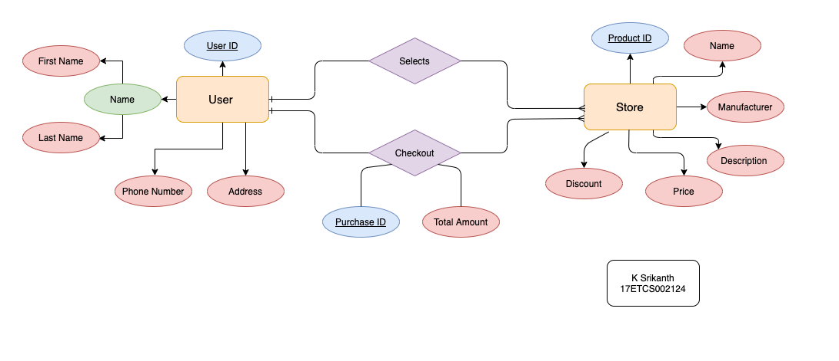

Class Diagram

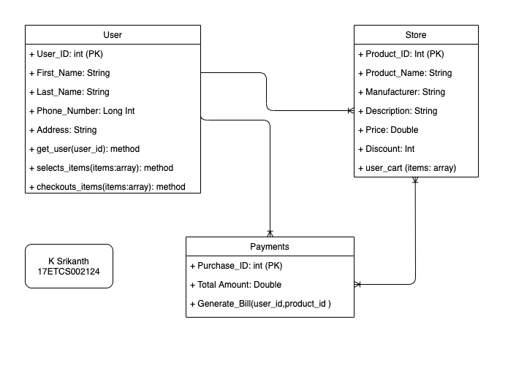

1. **Creation of the database**

Steps to Create a database

1. create database exam
2. use exam
3. create table store (product_id int,name varchar(50),manufacturer varchar(50),price double(10,0),discount(10,0),description varchar(100),primary key(product_id))
4. insert into store values (1,”dell latitude e6420”,”dell”,20000,15,”Nice Laptop”)



Figure 1 Image Showing the metadata for the database



Figure 2 Image Showing the data in the database

1. **Source Code with documentation**



1. **Results**



1. **Analysis and Discussion**

Successfully conducted the given questions without any errors. Completed the given task of displaying the database details in HTML page in a table format, where laptops list which are at discount above 20%. All the code is executed in a PHP header inside <body> tag.